# Baldivis Secondary College

### Semester One Examination, 2017

### Question/Answer booklet

# MATHEMATICS

**SOLUTIONS**

**SPECIALIST**

**UNIT 1**

## Section Two:

## Calculator-assumed

|  |  |  |  |  |  |  |  |  |  |  |
| --- | --- | --- | --- | --- | --- | --- | --- | --- | --- | --- |
| Student Number: In figures |  |  |  |  |  |  |  |  |  |  |

In words

Your name

## Time allowed for this section

Reading time before commencing work: ten minutes

Working time: one hundred minutes

## Materials required/recommended for this section

***To be provided by the supervisor***

This Question/Answer booklet

Formula sheet (retained from Section One)

***To be provided by the candidate***

Standard items: pens (blue/black preferred), pencils (including coloured), sharpener, correction fluid/tape, eraser, ruler, highlighters

Special items: drawing instruments, templates, notes on two unfolded sheets of A4 paper, and up to three calculators approved for use in this examination

## Important note to candidates

No other items may be taken into the examination room. It is **your** responsibility to ensure that you do not have any unauthorised material. If you have any unauthorised material with you, hand it to the supervisor **before** reading any further.

## Structure of this paper

|  |  |  |  |  |  |
| --- | --- | --- | --- | --- | --- |
| Section | Number of questions available | Number of questions to be answered | Working  time (minutes) | Marks available | Percentage of examination |
| Section One:  Calculator-free | 6 | 6 | 50 | 52 | 35 |
| Section Two:  Calculator-assumed | 12 | 12 | 100 | 96 | 65 |
|  | | |  | **Total** | 100 |

## Instructions to candidates

1. The rules for the conduct of examinations are detailed in the school handbook. Sitting this examination implies that you agree to abide by these rules.

2. Write your answers in this Question/Answer booklet.

3. You must be careful to confine your response to the specific question asked and to follow any instructions that are specified to a particular question.

4. Additional working space pages at the end of this Question/Answer booklet are for planning or continuing an answer. If you use these pages, indicate at the original answer, the page number it is planned/continued on and write the question number being planned/continued on the additional working space page.

5. Show all your working clearly. Your working should be in sufficient detail to allow your answers to be checked readily and for marks to be awarded for reasoning. Incorrect answers given without supporting reasoning cannot be allocated any marks. For any question or part question worth more than two marks, valid working or justification is required to receive full marks. If you repeat any question, ensure that you cancel the answer you do not wish to have marked.

6. It is recommended that you do not use pencil, except in diagrams.

7. The Formula sheet is not to be handed in with your Question/Answer booklet.

Section Two: Calculator-assumed 65% (96 Marks)

This section has**twelve (****12)** questions. Answer **all** questions. Write your answers in the spaces provided.

Working time: 100 minutes.

Question 7 (6 marks)

A music playlist contains nine different tracks, including one called First Night and another called Last Night. Each track is three minutes long.

(a) A shuffle feature randomly arranges the nine tracks. Determine the number of all possible arrangements that

(i) start with First Night. (1 mark)

|  |
| --- |
| **Solution** |
|  |
| **Specific behaviours** |
| ✓ states number |

(ii) start with First Night and end with Last Night. (1 mark)

|  |
| --- |
| **Solution** |
|  |
| **Specific behaviours** |
| ✓ states number |

(iii) start with First Night or end with Last Night. (2 marks)

|  |
| --- |
| **Solution** |
|  |
| **Specific behaviours** |
| ✓ uses inclusion-exclusion principle  ✓ states correct number |

(b) Determine the number of selections of different tracks from the playlist that do not include First Night and Last Night and have a total playtime of 15 minutes. (2 marks)

|  |
| --- |
| **Solution** |
|  |
| **Specific behaviours** |
| ✓ calculates number of tracks  ✓ states number of selections |

Question 8 (5 marks)

In the diagram below, and are diameters of the circle with centre , lies on the circumference and .

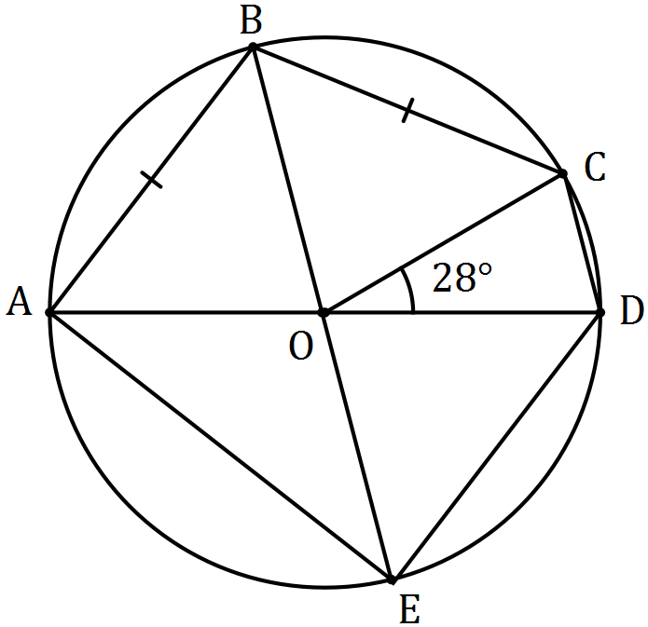

Determine the sizes of the following angles.

(a) . (2 marks)

|  |
| --- |
| **Solution** |
|  |
| **Specific behaviours** |
| ✓ indicates congruent angles  ✓ calculates angle |

(b) . (1 mark)

|  |
| --- |
| **Solution** |
|  |
| **Specific behaviours** |
| ✓ states angle |

(c) . (2 marks)

|  |
| --- |
| **Solution** |
|  |
| **Specific behaviours** |
| ✓ indicates size of  ✓ calculates angle |

Question 9 (8 marks)

Two tugs pull an offshore drilling rig. The first tug applies a force of 5 500 N in direction 122° and the second tug applies a force of 6 000 N in direction 088°.

(a) Show that the resultant force applied by the two tugs has magnitude close to 11 000 N, and determine the angle that the resultant force makes with the direction of the force applied by the first tug boat. (5 marks)

|  |
| --- |
| **Solution** |
|  |
| **Specific behaviours** |
| ✓ sketch  ✓ uses cosine rule  ✓ shows magnitude before rounding  ✓ uses sine rule  ✓ determines angle |

(b) The second tug boat is asked to decrease the magnitude of the force it applies to reduce the resultant force to 9 000 N. Determine the percentage decrease required. (3 marks)

|  |
| --- |
| **Solution** |
|  |
| **Specific behaviours** |
| ✓ uses cosine rule  ✓ solves for magnitude  ✓ determines % reduction |

Question 10 (8 marks)

Three vectors , and are non-zero and non-parallel.

(a) Sketch a diagram using the parallelogram rule to show that vector addition is commutative, that is . (2 marks)

|  |
| --- |
| **Solution** |
|  |
| **Specific behaviours** |
| ✓ shows and nose to tail with resultant  ✓ completes parallelogram with and nose to tail |

(b) Sketch a diagram to clearly illustrate each of the following vector equations.

(i) . (2 marks)

|  |
| --- |
| **Solution** |
|  |
| **Specific behaviours** |
| ✓ closed triangle  ✓ vectors labelled and directed |

(ii) . (2 marks)

|  |
| --- |
| **Solution** |
|  |
| **Specific behaviours** |
| ✓ closed triangle  ✓ vectors labelled and directed |

(c) If , then is it also true that ? Explain your answer. (2 marks)

|  |
| --- |
| **Solution** |
| For most cases, it is not true.  However, it is true when . |
| **Specific behaviours** |
| ✓ states for most case (but not all)  ✓ states case when is true |

Question 11 (8 marks)

(a) In the diagram, , , and lie on the circumference of circle with centre . Given that , and determine the values of , and . (3 marks)

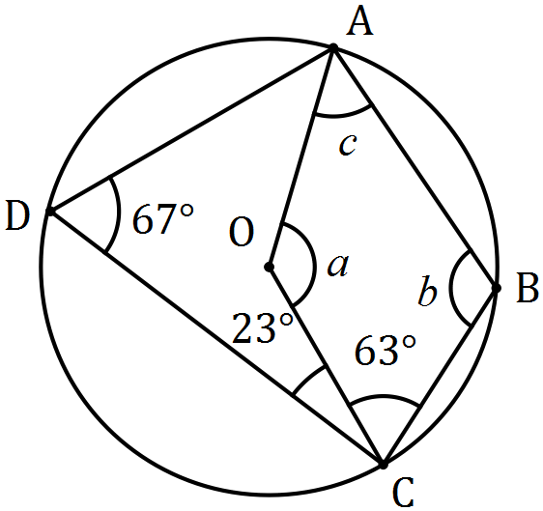

|  |
| --- |
| **Solution** |
|  |
| **Specific behaviours** |
| ✓  ✓  ✓ |

(b) In the diagram below, points , and lie on the circumference of circle centre and and are tangents to the circle.

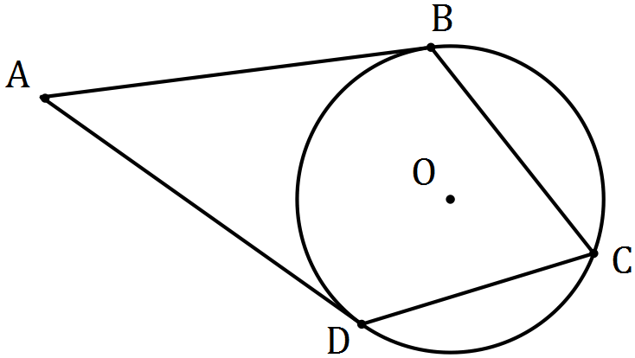

(i) Prove that is a cyclic quadrilateral. (3 marks)

|  |
| --- |
| **Solution** |
| (tangent-radii angle).  Hence .  Hence is a cyclic quadrilateral, as opposite angles and are supplementary. |
| **Specific behaviours** |
| ✓ indicates tangent-radii are at 90°  ✓ indicates opposite pair of angles are supplementary  ✓ writes conclusion |

(ii) Determine the size of if the size of . (2 marks)

|  |
| --- |
| **Solution** |
|  |
| **Specific behaviours** |
| ✓ determines  ✓ determines |

Question 12 (8 marks)

A seaplane with a cruising speed of 250 kmh-1 is required to fly to a location 355 km away on a bearing of 305°. A wind of 36 kmh-1 is blowing from bearing 020°.

(a) Sketch a diagram to show this information. (2 marks)

|  |
| --- |
| **Solution** |
|  |
| **Specific behaviours** |
| ✓ includes required path  ✓ includes bearings or 105° angle in triangle |

(b) Determine the bearing that the seaplane should steer. (3 marks)

|  |
| --- |
| **Solution** |
|  |
| **Specific behaviours** |
| ✓ uses sine rule  ✓ solves triangle  ✓ states bearing |

(c) Determine the flight time, in hours and minutes. (3 marks)

|  |
| --- |
| **Solution** |
|  |
| **Specific behaviours** |
| ✓ uses sin or cosine rule  ✓ determines  ✓ states in h:m |

Question 13 (9 marks)

Seven teams from WA, six teams from SA and five teams from NT apply for eight available places in a league competition. The league is run so that every team plays every other team exactly once and no game ends in a tie.

(a) The organisers decide that there must be at least four teams from WA and an equal number of teams from SA and NT. Determine the total number of ways in which the organisers can select the eight teams for the league. (3 marks)

|  |
| --- |
| **Solution** |
|  |
| **Specific behaviours** |
| ✓ identifies ways to select teams using combinations  ✓ shows use of multiplication and addition  ✓ calculates correct number |

Assume the eight teams have already been chosen.

(b) Determine the number of games that will be played in the league and hence the number of schedules possible for the first three games. (3 marks)

|  |
| --- |
| **Solution** |
|  |
| **Specific behaviours** |
| ✓ calculates games required  ✓ uses permutation to arrange  ✓ evaluates number of ways |

(c) Use the pigeon hole principle to show that if no team loses all its games, then at least two teams finish the competition with the same number of wins. (3 marks)

|  |
| --- |
| **Solution** |
| There are 7 pigeonholes, labelled with the number of possible wins for each team: {1, 2, 3, 4, 5, 6, 7} - no team loses all games and each team plays 7 others.  But there are 8 numbers to go into these pigeonholes (the number of wins by each of the 8 teams).  So at least one of the pigeonholes must contain two numbers, and so at least two teams must finish the competition with the same number of wins. |
| **Specific behaviours** |
| ✓ identifies pigeonholes  ✓ identifies pigeons  ✓ explains result |

Question 14 (8 marks)

Three vectors are given by , and , where is a constant.

(a) Determine the vector projection of on . (3 marks)

|  |
| --- |
| **Solution** |
|  |
| **Specific behaviours** |
| ✓ states unit vector for  ✓ states  ✓ states projection as vector |

(b) Determine the value(s) of if

(i) and are perpendicular. (2 marks)

|  |
| --- |
| **Solution** |
|  |
| **Specific behaviours** |
| ✓ uses scalar product  ✓ states value of |

(ii) the angle between the directions of and is 45°. (3 marks)

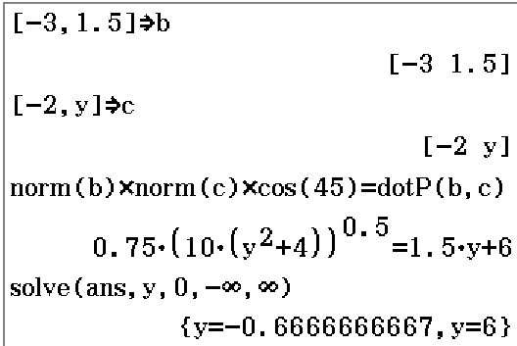

|  |
| --- |
| **Solution** |
|  |
| **Specific behaviours** |
| ✓ uses scalar product  ✓ states one solution  ✓ states second solution  (CAS is quickest if use numerical solve as shown) |

Question 15 (9 marks)

(a) The work done, in joules, by a force of Newtons in changing the displacement of an object by metres, is given by the scalar product of and .

(i) A force of 250 N acting due south moves an object 4.3 m in a south-westerly direction. Determine the work done. (2 marks)

|  |
| --- |
| **Solution** |
|  |
| **Specific behaviours** |
| ✓ substitutes correctly  ✓ evaluates work done |

(ii) Another force of 155 N does 269 joules of work in moving an object 190 cm. Determine the angle between the force and the direction of movement. (2 marks)

|  |
| --- |
| **Solution** |
|  |
| **Specific behaviours** |
| ✓ substitutes correctly  ✓ evaluates angle |

(b) A triangle is formed by three non-zero vectors , and , so that , and is the angle between and .

|  |
| --- |
| **Solution** |
|  |
| **Specific behaviours** |
| ✓ sketch |

(i) Sketch the triangle. (1 mark)

(ii) Explain why . (1 mark)

|  |
| --- |
| **Solution** |
| using definition of scalar product, since and , then . |
| **Specific behaviours** |
| ✓ explanation |

(iii) Use to deduce the cosine rule. (3 marks)

|  |
| --- |
| **Solution** |
|  |
| **Specific behaviours** |
| ✓ expands scalar product  ✓ uses result from (ii)  ✓ uses scalar product definition |

Question 16 (10 marks)

In the diagram below, is a diameter of circle with centre , is a tangent to the circle at , is a tangent to the circle at and is extended to meet extended at . You may want to let .

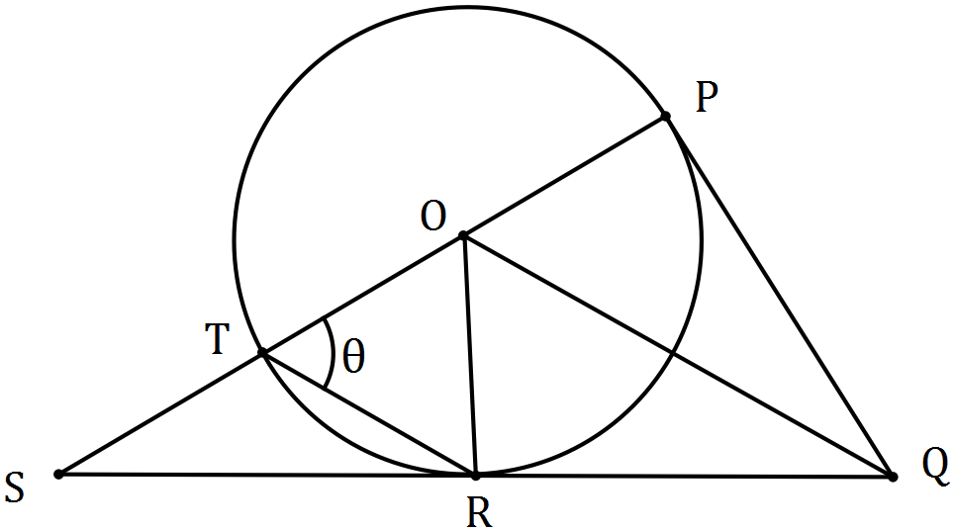

(a) Prove that is congruent to . (3 marks)

|  |
| --- |
| **Solution** |
| (i) (radii)  (ii) (tangent length from external point)  (iii) (common to both triangles)  (iv) (tangent-radius angle 90°)  Using various combinations, reason one of SSS, SAS or RHS. |
| **Specific behaviours** |
| ✓ first statement with reason  ✓ second and third statements with reasons  ✓ relevant conclusion |

(b) Prove that is parallel to . (4 marks)

|  |
| --- |
| **Solution** *(one of many possibilities)* |
| Given , then (as isosceles - and radii)  Hence (sum of interior angles opposite exterior angle)  Hence (congruent triangles, )  Hence (corresponding angles equal)  Hence is parallel to |
| **Specific behaviours** |
| ✓ uses isosceles triangle  ✓ determines  ✓ determines  ✓ uses corresponding angles to make conclusion |

(c) If , deduce that is equilateral. (3 marks)

|  |
| --- |
| **Solution** |
| is isosceles.  Hence (sum of interior angles opposite exterior angle)  But (tangent-radius angle 90°)  Hence .  Hence - is equilateral. |
| **Specific behaviours** |
| ✓ expresses using isosceles triangle  ✓ expresses using radii-tangent angle  ✓ solves for and deduces triangle is equilateral |

Question 17 (11 marks)

A small boat that can maintain a steady speed of 5 ms-1 is to cross a river from to , where .

A current of flows in the river.

The velocity vector that the pilot of the small boat must set to travel from to is , where and are constants.

(a) Explain why and , where is a constant. (3 marks)

|  |
| --- |
| **Solution** |
| The sum of the velocities of the boat and the river must be parallel to :  The two given equations arise by equating and then coefficients from this equation. |
| **Specific behaviours** |
| ✓ uses sum of velocities  ✓ uses equation for parallel condition  ✓ equates individual coefficients |

(b) Eliminate from the equations in (a) and hence express in terms of , simplifying your expression. (3 marks)

|  |
| --- |
| **Solution** |
|  |
| **Specific behaviours** |
| ✓ equates both to t  ✓ cross-multiplies  ✓ simplifies |

(c) Explain why . (1 mark)

|  |
| --- |
| **Solution** |
| The magnitude of is the speed of the boat. |
| **Specific behaviours** |
| ✓ uses magnitude and speed |

(d) Use your equations from (b) and (c) to determine the values of and . (3 marks)

|  |
| --- |
| **Solution** |
|  |
| **Specific behaviours** |
| ✓ writes equation  ✓ solves for and  ✓ eliminates alternative solution |

(e) Determine the time that the small boat will take to travel from to . (1 mark)

|  |
| --- |
| **Solution** |
|  |
| **Specific behaviours** |
| ✓ states time |

Question 18 (6 marks)

Let .

(a) Use an example to show that when is odd, is even. (1 mark)

|  |
| --- |
| **Solution** |
|  |
| **Specific behaviours** |
| ✓ suitable example |

(b) Write the contrapositive of "if is an even integer, then is an odd integer". (1 mark)

|  |
| --- |
| **Solution** |
| If is **not** odd, then is **not** even. |
| **Specific behaviours** |
| ✓ writes contrapositive |

Any even integer can be expressed in the form , where . Similarly, any odd integer can be expressed in the form .

(c) Simplify . (1 mark)

|  |
| --- |
| **Solution** |
|  |
| **Specific behaviours** |
| ✓ substitutes and simplifies |

(d) Express in a form that clearly shows it is an odd integer. (1 mark)

|  |
| --- |
| **Solution** |
|  |
| **Specific behaviours** |
| ✓ expresses in form |

(e) Use your answers above to prove that if is even, then is odd. (2 marks)

|  |
| --- |
| **Solution** |
| (c) and (d) prove that when is not odd (ie even) then is not even (ie odd).  Hence the contrapositive statement from (b) is true and so the original statement that is to be proved must be true. |
| **Specific behaviours** |
| ✓ uses results from (c) and (d)  ✓ explains contrapositive is true and hence statement must be true |

Additional working space

Question number: _________

Additional working space

Question number: _________

Additional working space

Question number: _________

© 2016 WA Exam Papers. Baldivis Secondary College has a non-exclusive licence to copy and communicate this paper for non-commercial, educational use within the school. No other copying, communication or use is permitted without the express written permission of WA Exam Papers. SN261-091-4.